**NAME**: mostafa ahmed abd-elbaset elsayed

مصطفي احمد عبدالباسط السيد

**B.N:** 896

**Topic :** artificial intelligence

**Github-link :** <https://github.com/mostafa-ahmed20/ece001>

**Github-page(published-website):**

**Application brief:**

**What is Artificial Intelligence?**

In the simplest terms, **artificial intelligence (AI)** refers to systems or machines that mimic human intelligence to perform tasks and can iteratively improve themselves based on the information they collect.  
**Artificial intelligence (AI)** makes it possible for machines to learn from experience ,Most AI examples that you hear about today from chess-playing computers to self-driving cars rely heavily on deep learning and natural language processing. Using these technologies, computers can be trained to accomplish specific tasks by processing large amounts of data and recognizing patterns in the data.  
**Artificial intelligence (AI)** is wide-ranging branch of computer science concerned with building smart machines capable of performing tasks that typically require human intelligence. AI is an interdisciplinary science with multiple approaches, but advancements in machine learning and deep learning are creating a paradigm shift in virtually every sector of the tech industry.Marketing is a way to sugar coat your products to attract more customers. We, humans, are pretty good at sugar coating, but what if an algorithm or a bot is built solely for the purpose of marketing a brand or a company? It would do a pretty awesome job! In the early 2000s, if we searched an online store to find a product without knowing it is exact name, it would become a nightmare to find the product.

**Screenshots** 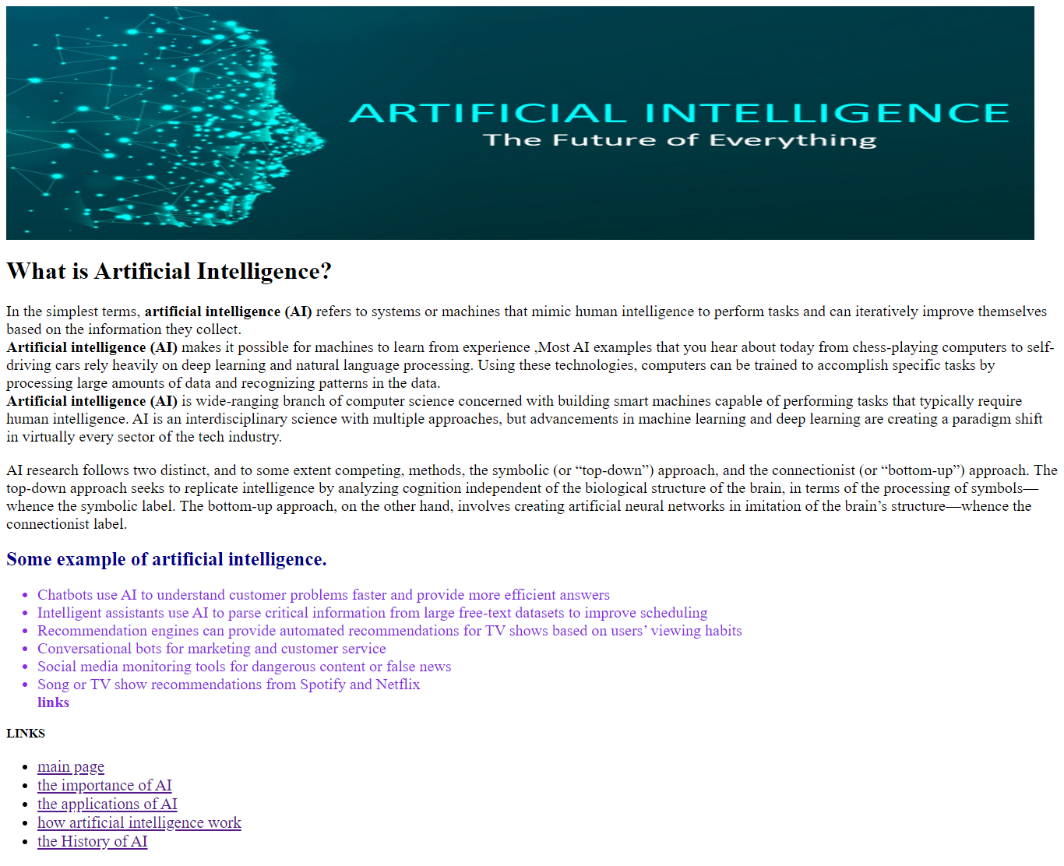

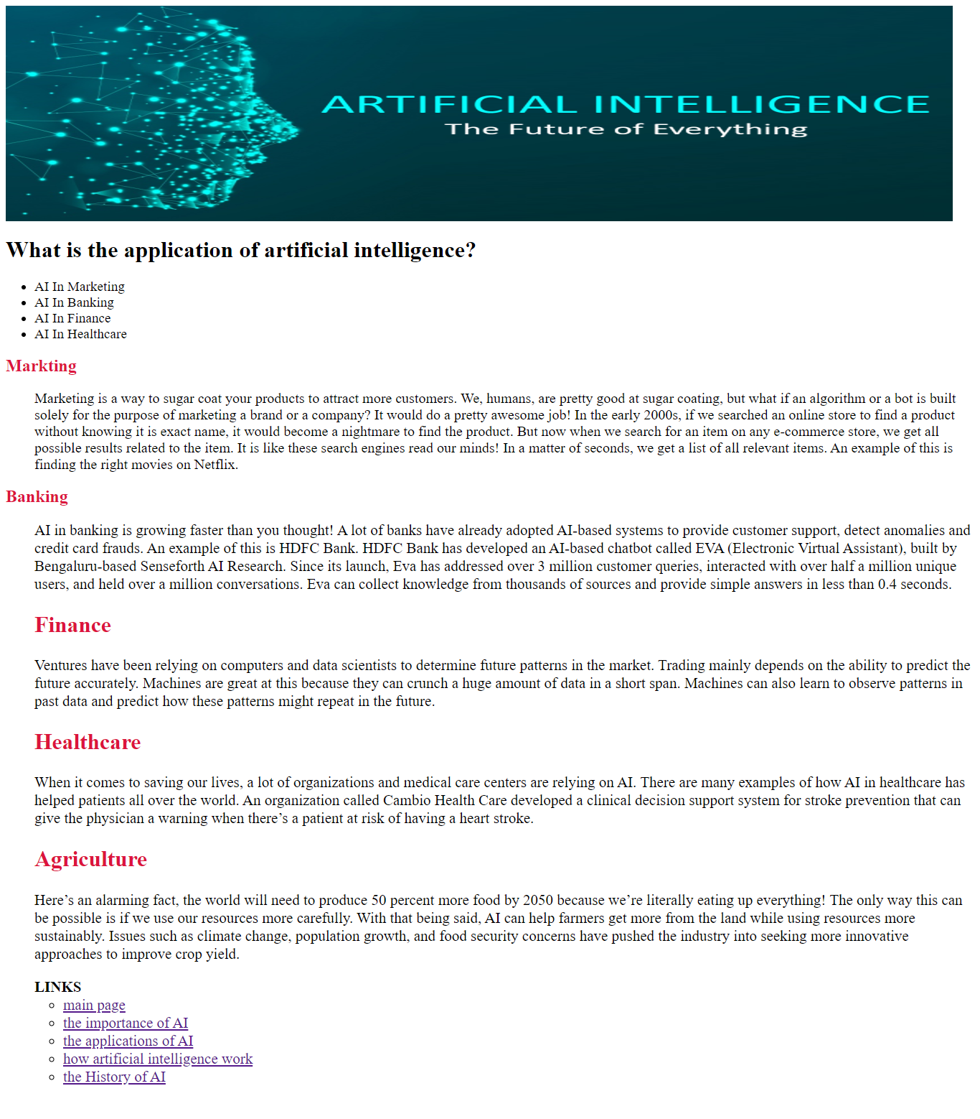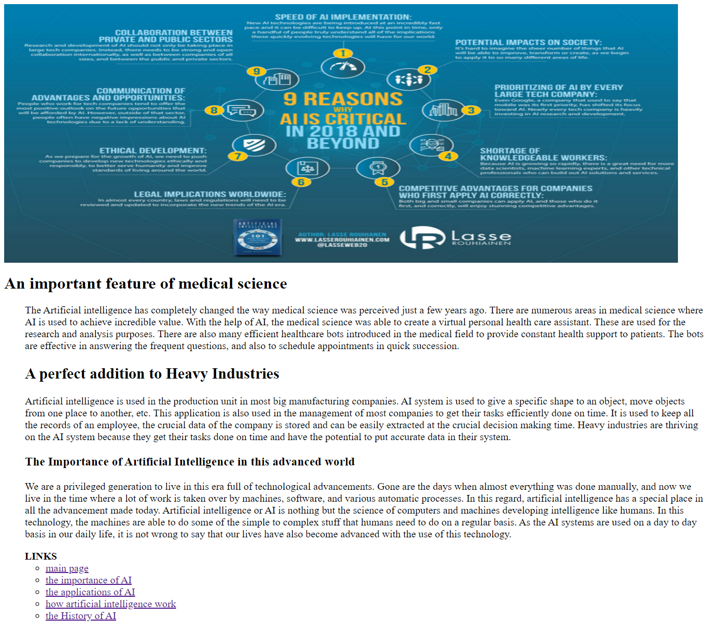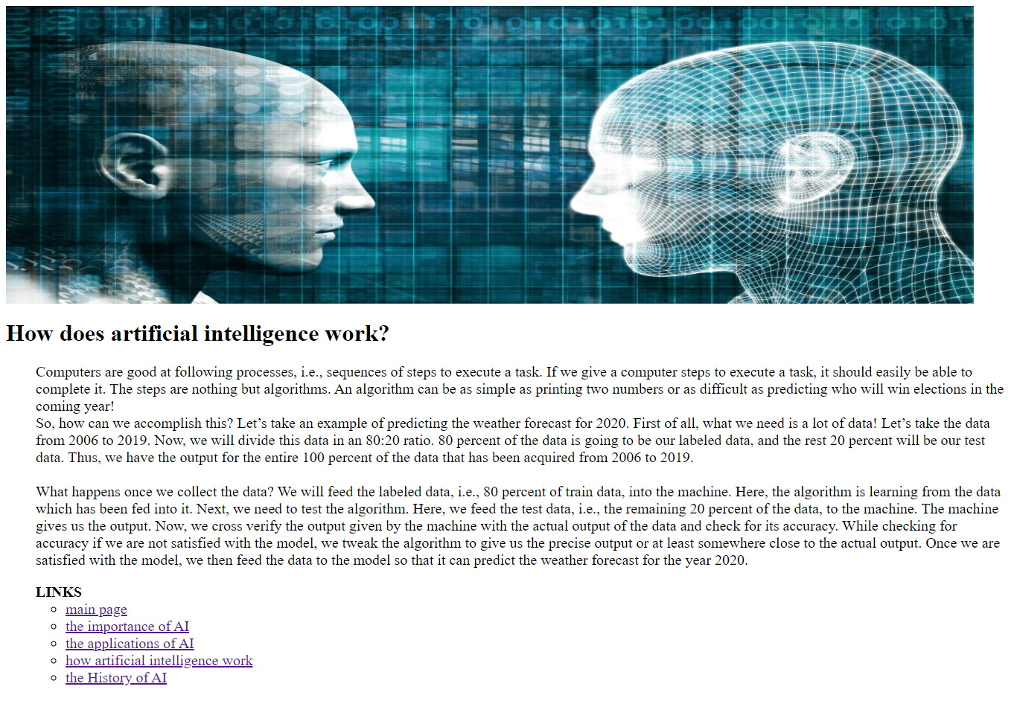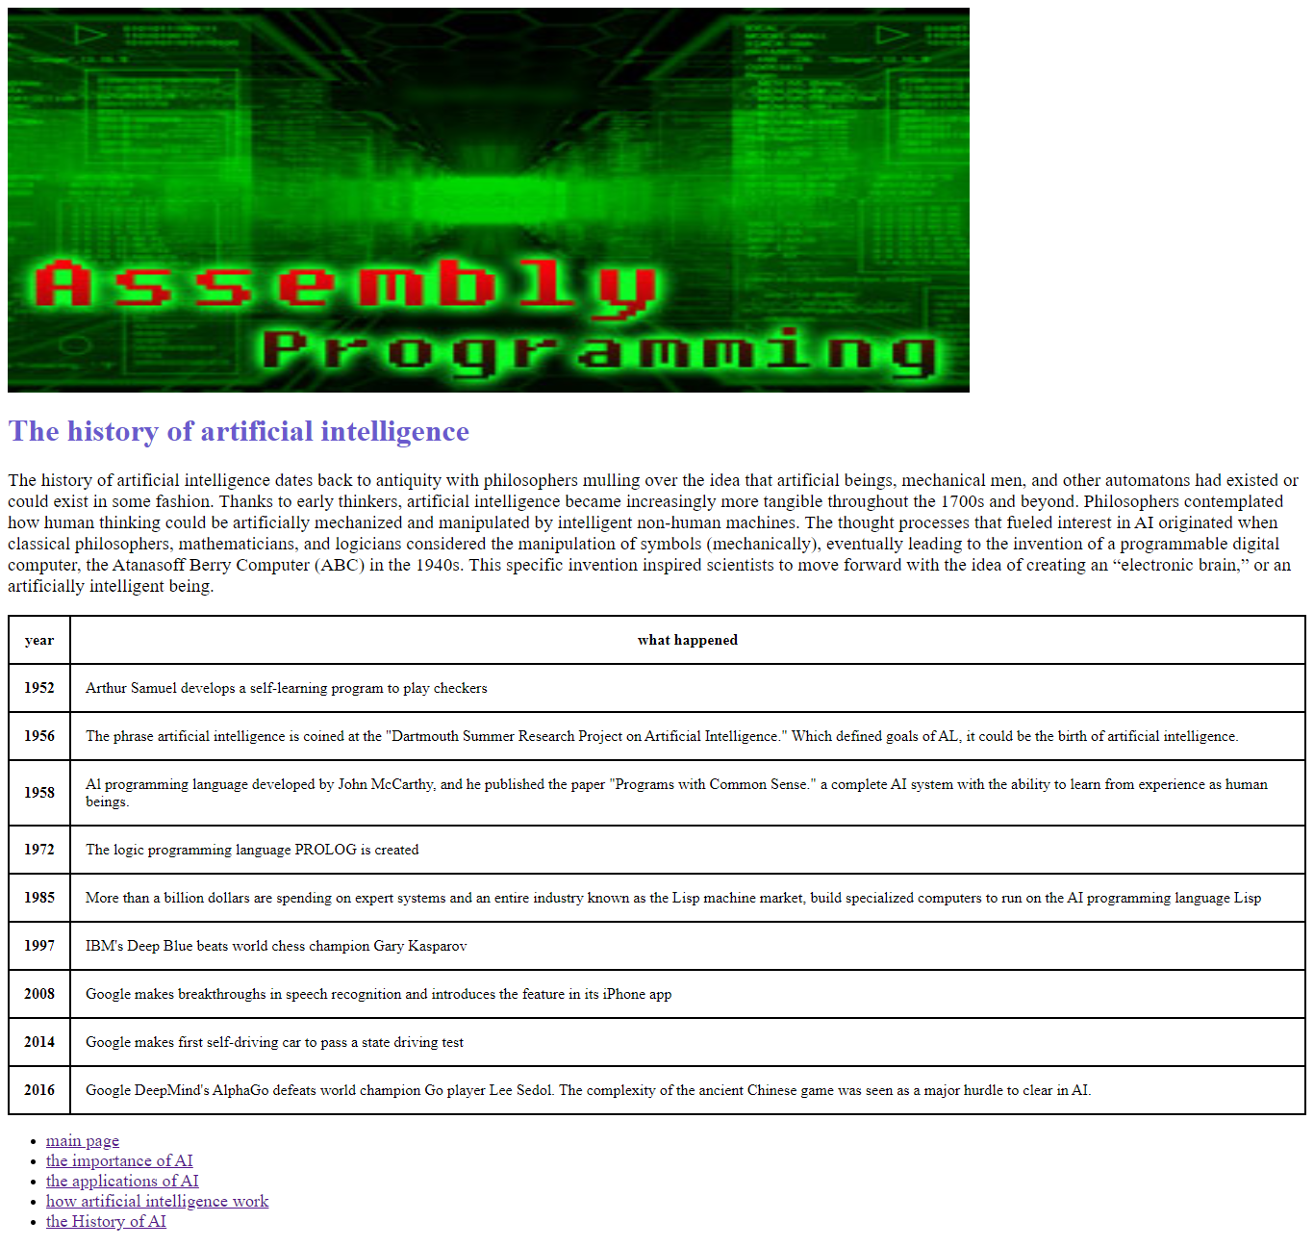

**Source code:**

